**Lisa Corinne Davis**

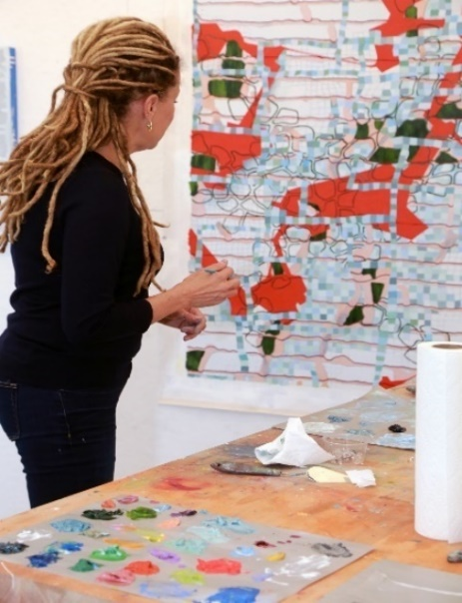

**Recommended by Lilly Wei as an important artist to have in a collection**

Lisa Corinne Davis is a New York-based artist best known for paintings and works on paper that resemble multilayered maps or similar constructs with encoded narratives. Her “inventive geography” prompts a wide range of interpretations, its open-endedness a state she actively cultivates. Her work derives from autobiographical sources as well as social and cultural concerns, referring to the historical as well as the contemporary, resulting in visually dynamic hybrids in style and subject. Davis, who is Black, says that has shaped her practice, as she explores the complex relationship between “race, culture and history” and with it, ideas about classification and contingency, the rational and irrational, chaos and order. Her painting has become increasingly assured, increasingly responsive to the processes of paint and its materiality. The colors are richer and more nuanced, her “environments” fluid, not quite representational, and not quite abstract, but tending toward the latter—interrupted grids, straight vertical bands overridden by repetitive sequences of undulations—all of it very much dependent upon what the viewer brings to the looking, to the seeing, to the reading.

*Lilly Wei, Fall 2020*

**Bio**

Lisa Corinne Davis is an abstract painter exploring themes of racial, social, and psychological identity. Born in Baltimore, MD, currently living and working in Brooklyn, NY, Davis received her BFA from Pratt Institute in 1980, and her MFA from Hunter College in 1983. Her paintings have been exhibited across the United States and in Europe, including one person shows at June Kelly Gallery (New York), Gerald Peters Gallery (New York), Zolla/Lieberman Gallery (Chicago), Spanierman Modern (Miami), and The Mayor Gallery (London). Her work is included in the collections of The Museum of Modern Art, the J. Paul Getty Museum, The Philadelphia Museum of Art, and the Victoria and Albert Museum. Davis is the recipient of numerous awards, including The Louis Comfort Tiffany Foundation Grant, a National Endowment for the Arts Visual Artist Fellowship, and three Artist Fellowships from The New York Foundation for the Arts. In 2017, she was inducted as a National Academician at the National Academy Museum & School. Her essays on art and culture have been published in the *Brooklyn Rail* and *Art Critical.* Davis has previously taught painting at the Cooper Union School of Art and Yale University; she is currently Professor of Art and Head of Painting at Hunter College in New York.

**Artist Statement**

Despite the realities of social and geographic mobility, society seeks to maintain definitive categories of racial, national, and ethnic groups. This categorization is the judging and defining function by which we attempt to make a simplified order of the world. My work explores this complex relationship of race, culture, and history, where form and content merge. I am trying to carve out a space that starts with fixed notions of racial perceptions but moves to contemporary modes of communication, which are fleet and fugitive, massively networked and hyper-extended. Yet paint on canvas remains as it ever was—static, material, refractory. Alert to the digital web in which we’re all caught, I am at the same time an ardent believer in the power of paint in all its irrefutable, sensual physicality.

The forms in my paintings are somewhat familiar, but essentially ephemeral and deliberately enigmatic. Viewers are given room to navigate the meanings and question why they are making certain determinations. By inviting a variety of associations, the forms remain unfixed, and can shift in a moment to a different read. My hope is that viewers will question their initial determinations and recognize how uncomfortable we are with states of flux. I look for ways to further codify the structure of information by pushing the work closer to abstraction in both the imagery and the ideas. Maps are used as a point of departure, but I try to work with the logic of the poet rather than that of the demographer in setting up categories, collecting data, and creating pseudo graphs and charts. I play with place as a geographical, metaphorical, and metaphysical concept, where intersecting worlds collide and give birth to intimations of mapped space, geopolitical realities of national borders; indications of population density and critical mass, and parts resembling errant engineering models or animated characters. I hope that these oblique narratives, shifting spaces and wandering images may open a way forward in allowing pictorial construction to become variables of thought and feeling. The medium of paint has the last word.